Report on Workshop on paper bag and paper pen making
As a Go Green initiative program a workshop on paper bag and paper pen making was conducted on 16/11/24, by R- SAIL - RCET in association with Art & Craft club-RCET, Environmental Forum and SSSDF at our College during 2 pm to 4 pm at room no. 409. The workshop was meant for first year students and they participated in the workshop with great interest and enthusiasm. The coordinators explained the importance of making eco- friendly paper bags and gave a demo on 'how to make paper bags and paper pen'. Students also implemented new ideas in decorating these paper bags.
It was a fruitful experience for all the participants. The motive behind this 'go green initiative ' is being nature friendly and in forming a sustainable environment by reducing the use of plastic bags.
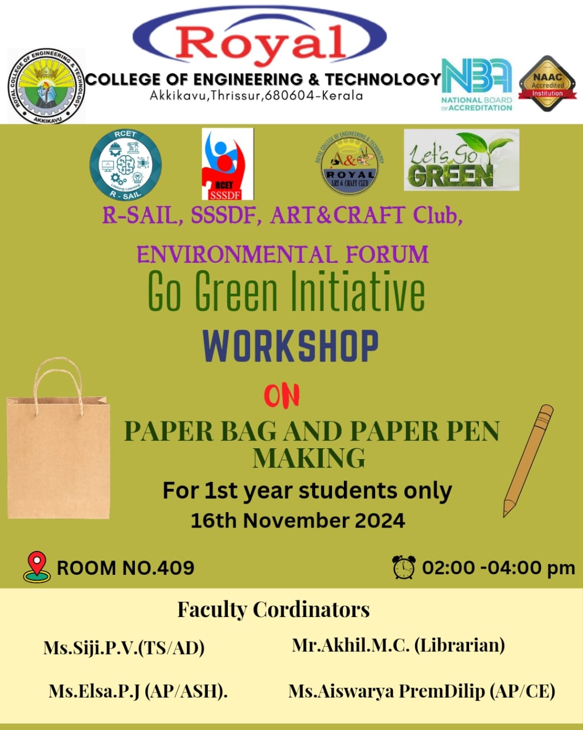
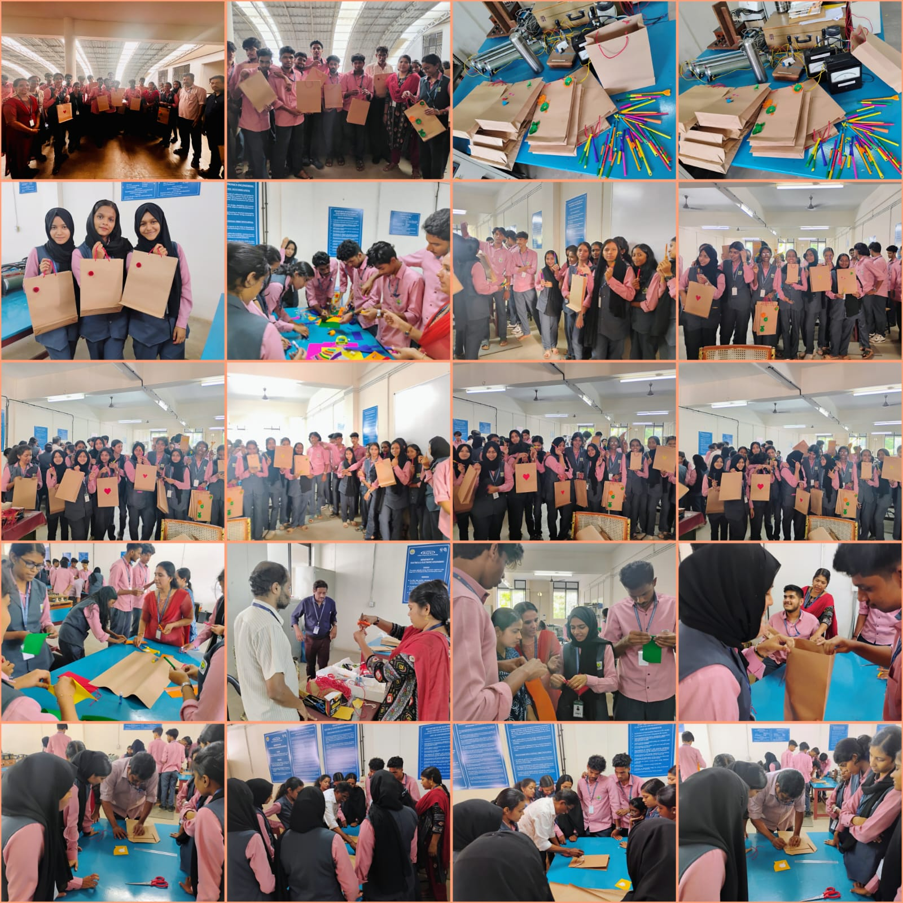

Report on WOOD ART with LED STRIP
A workshop on WOOD ART with LED STRIP was conducted on 30/11/24, by R- SAIL - RCET in association with IEDC, Art & Craft club-RCET, Environmental Forum and SSSDF from 2 pm to 4 pm at Mechanical Workshop & room no. 409. The workshop was meant for first year students and they participated in the workshop with great energy. The coordinators explained and illustrated a demo on 'how to do the wood art with LED strip. Students divided in to groups and made different designs. It was a nice experience for all the participants. The ‘X’ mas items made by the students were displayed for sale.
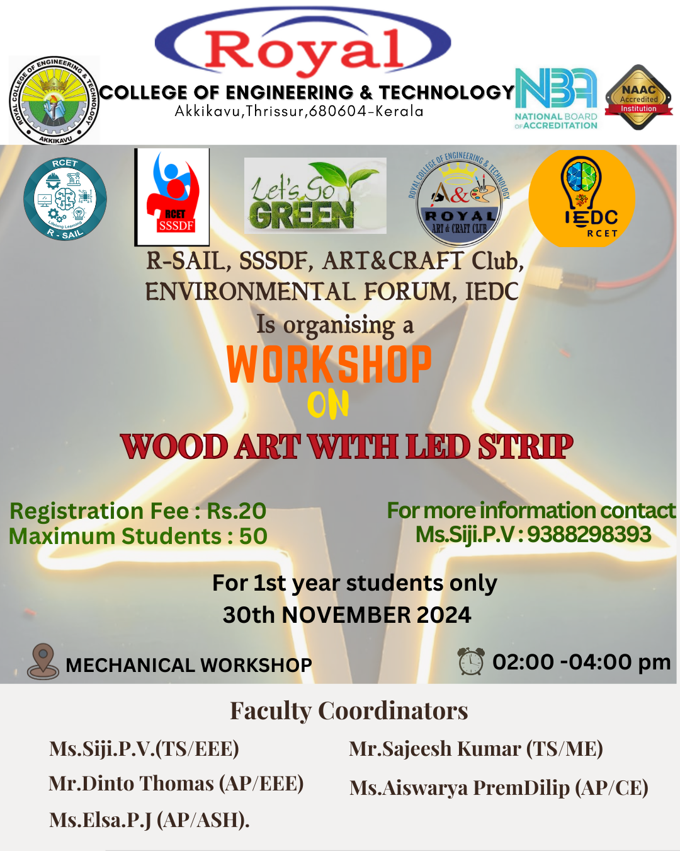

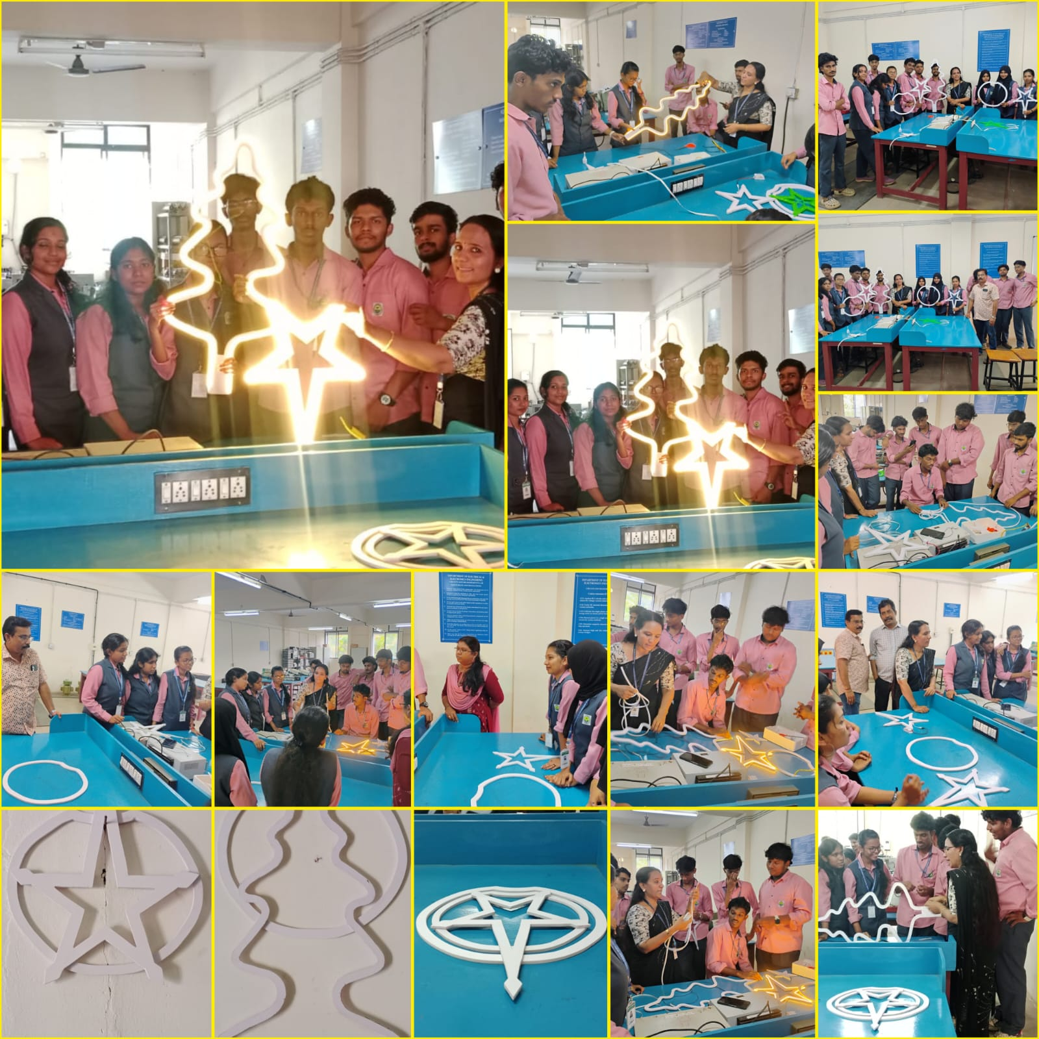
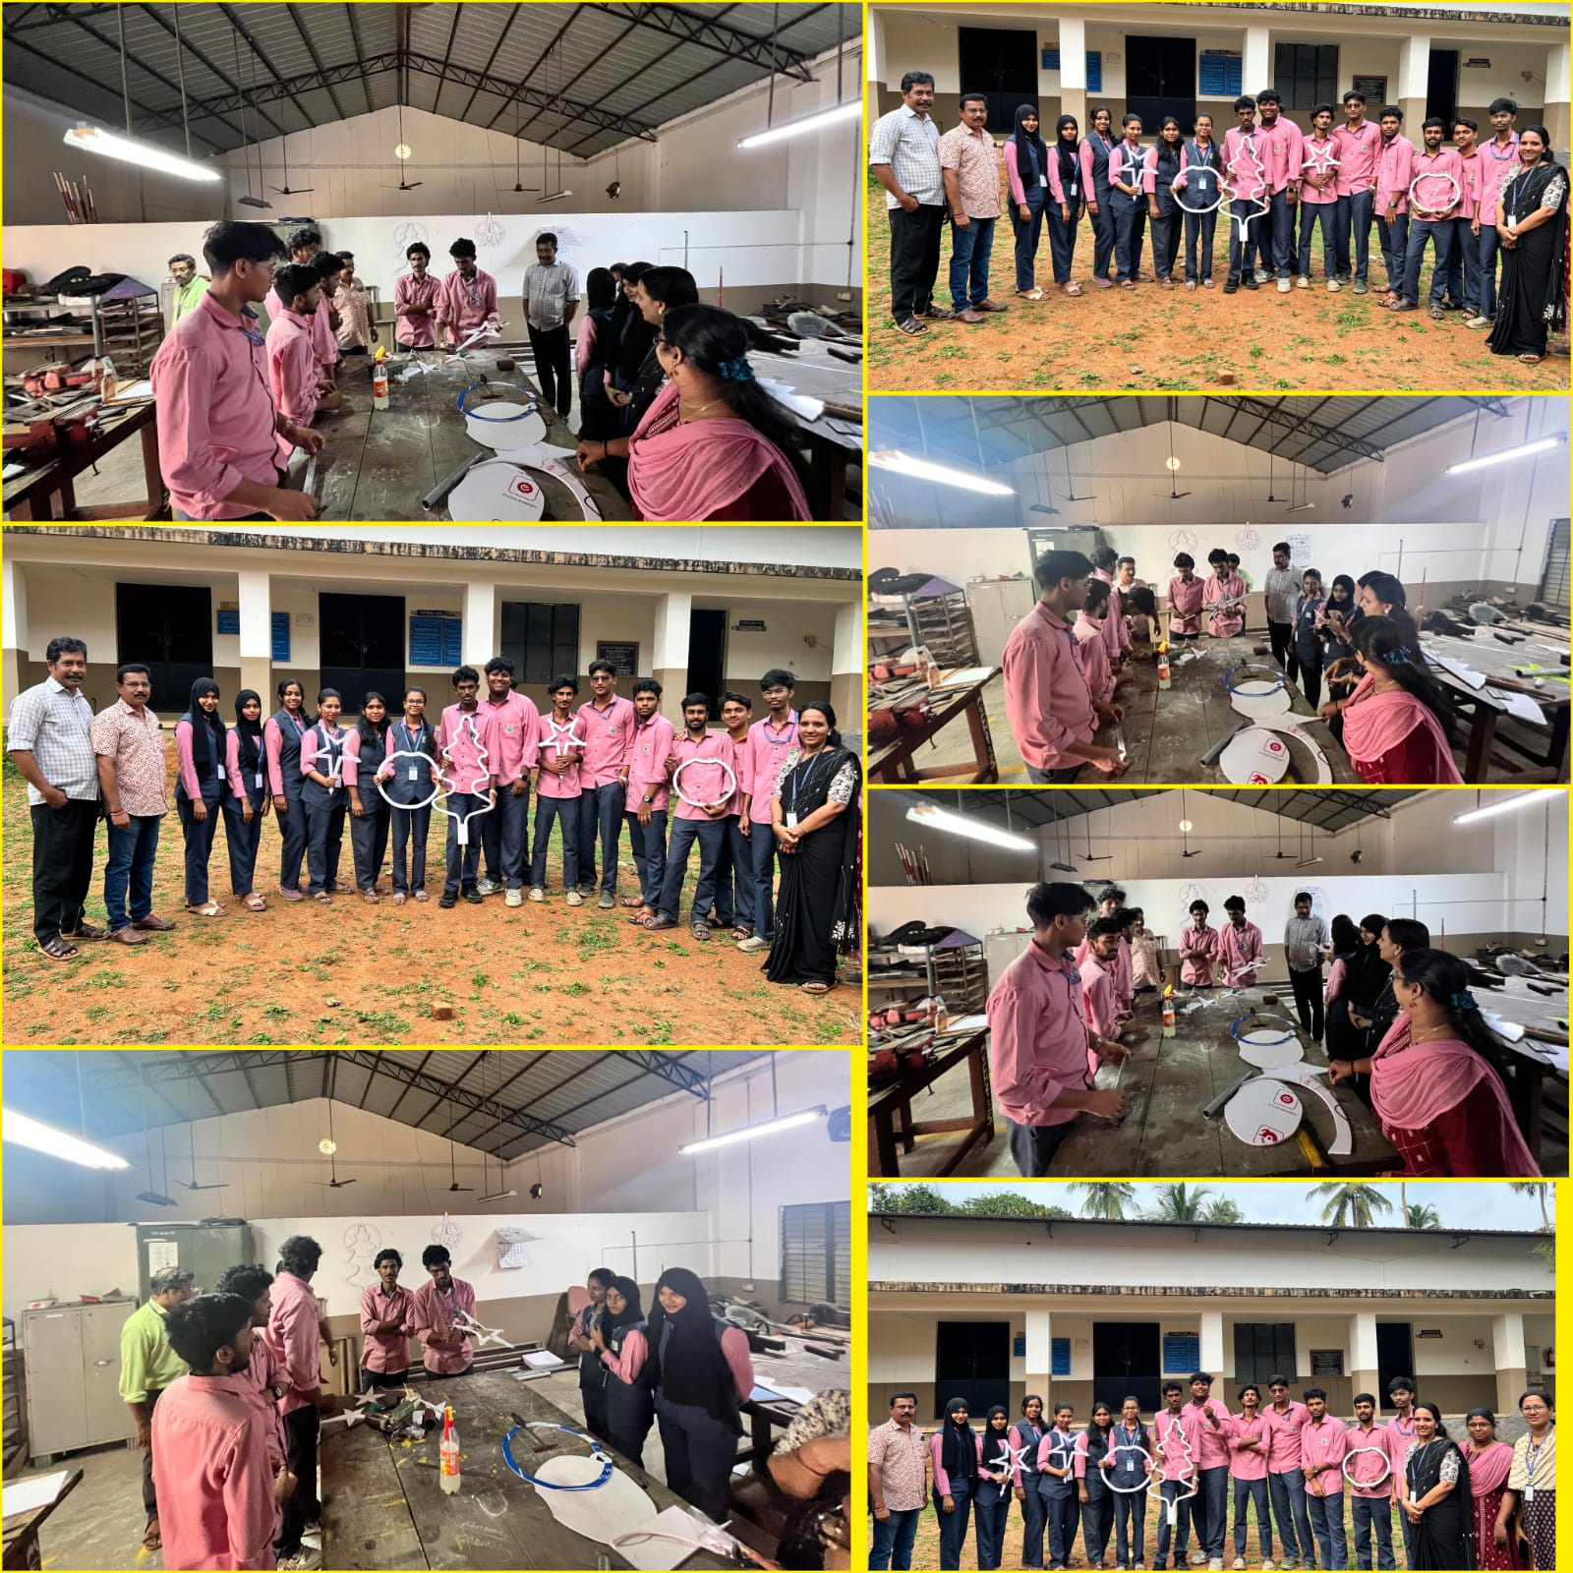
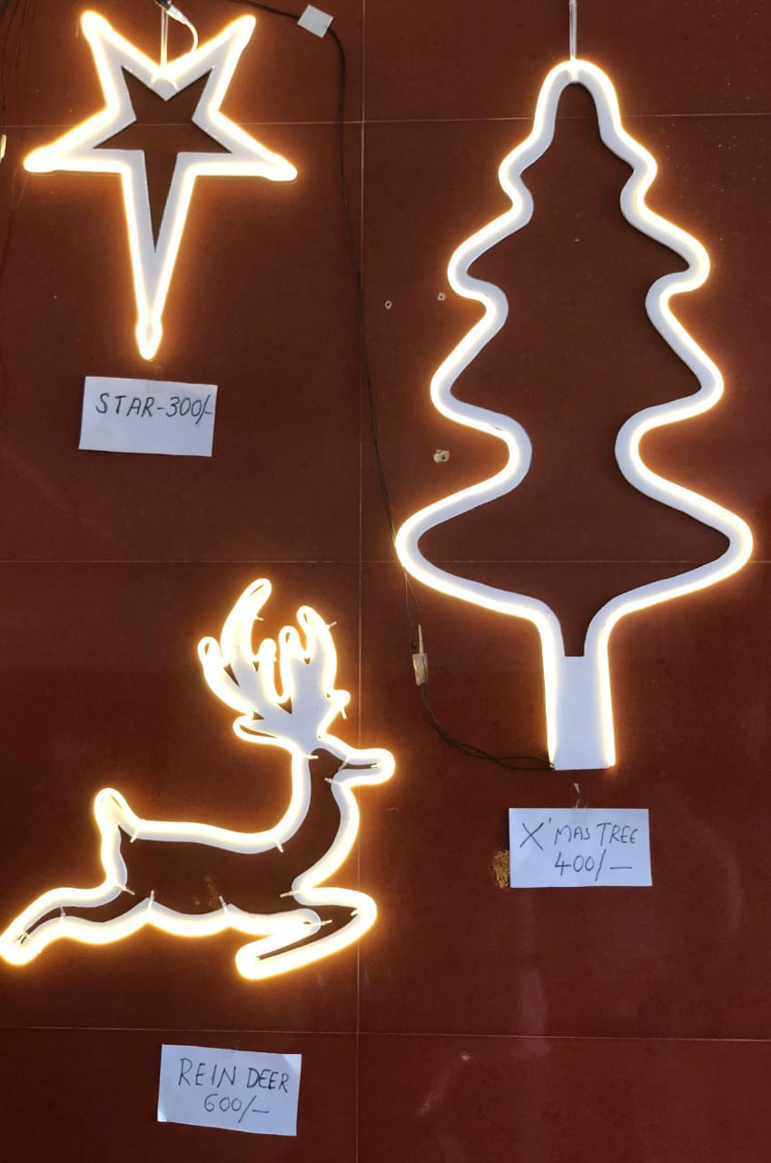
Items made by the students for sale

